**Docker Task**

Install docker on EC2 and explore the docker commands (docker images, containers, volumes, network)

**Install docker on EC2**

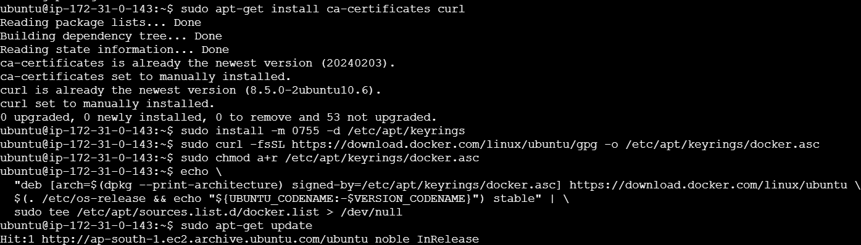

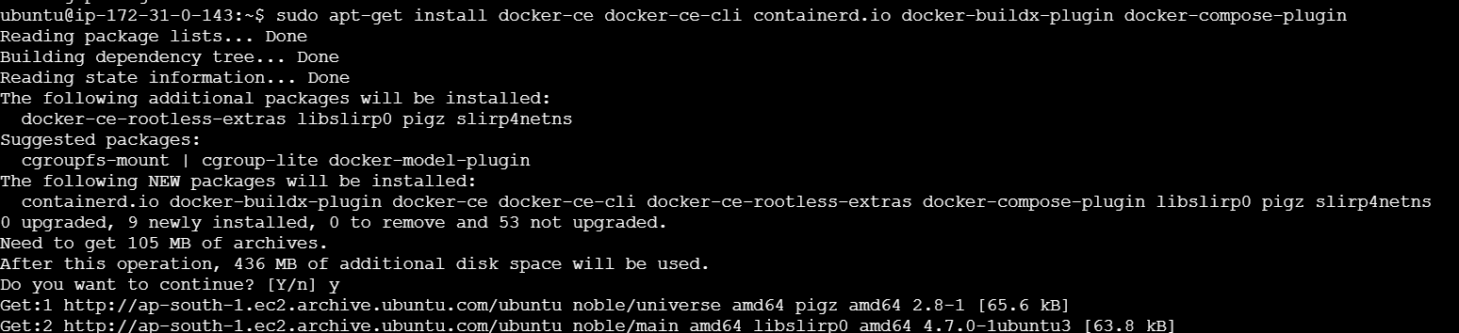

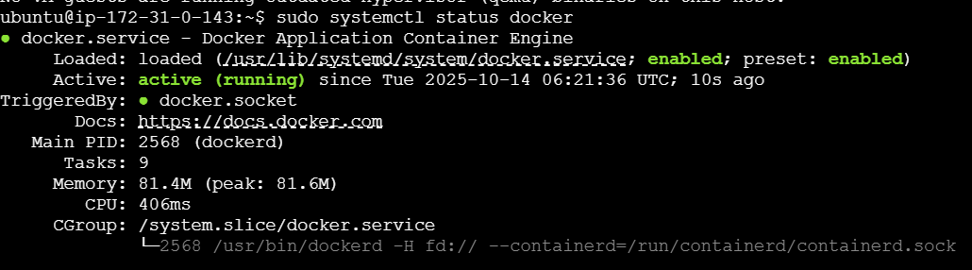

**Explore Important Docker Commands**

1. **Docker Images**

**Pull a specific image from Docker Hub (e.g., Mongodb):**

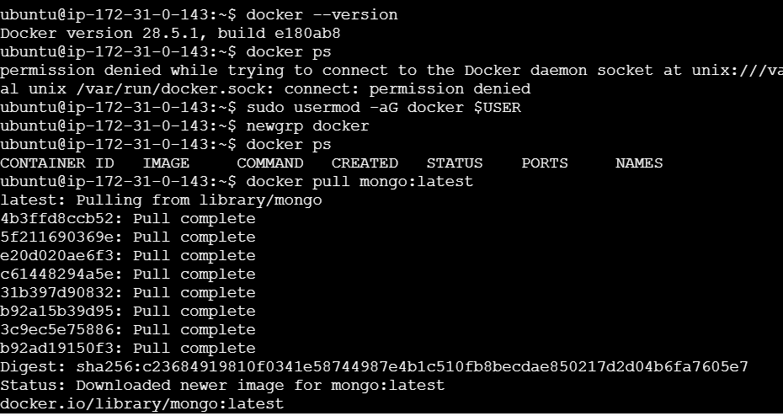

**Pull a specific image from Docker Hub (e.g., Nginx):**

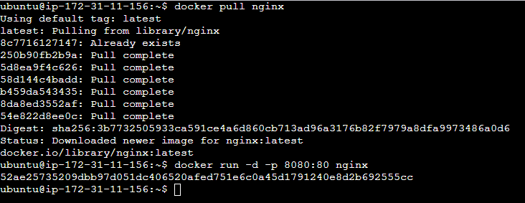

1. **Docker Containers**

**Run a container:**



**Stop and remove a container:**

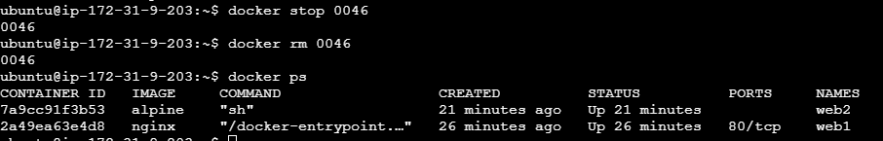

**3. Docker Volumes (for persistent data)**

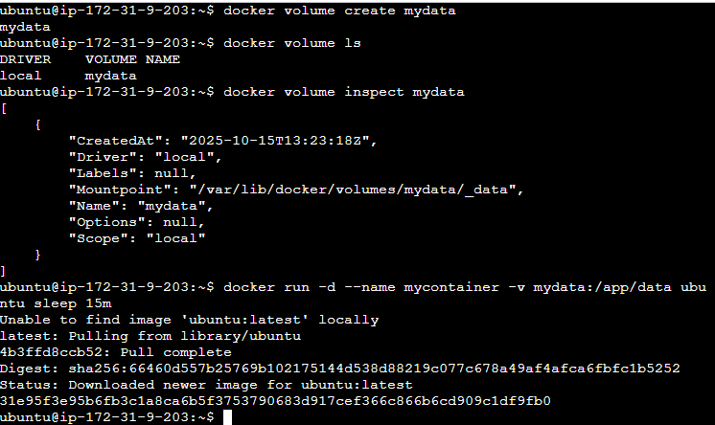

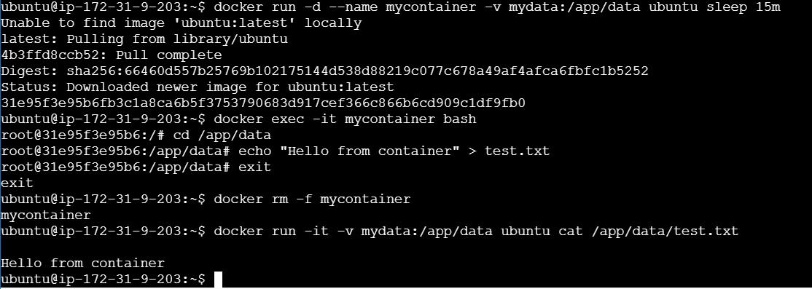

**4. Docker Networks**

